Chemie 4.5-10.5

1.
a) 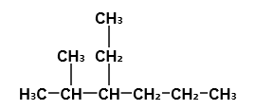
b)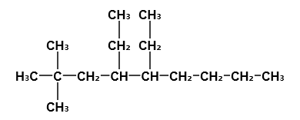
c) 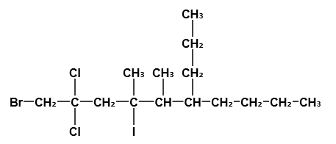

2.
a) 4-methylpentan
b) 6-Butan-5-ethyl-2-methylheptan
c) 7-Brom-6-methyl-3-propylnonan
d) 5-Butyl-2,3-Dibrom-3-Chlor-4-Ethyl-2-Fluor-7-methyl-9-propylundecan

3.
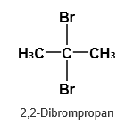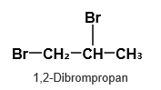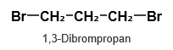

4.
a) C₅H₁₂ + 8 O₂ -> 5 CO₂ + 6 H₂O
b) 2 C₄H₁₀ + 13 O₂ -> 8 CO₂ + 10 H₂O

c) C₃H₈ + F₂ -> C₃H₇F + HF

C₃H₈ + -> C₃H₇

